A MUSICAL EVENING IN MEMORY OF

MAISIE ALLANSON

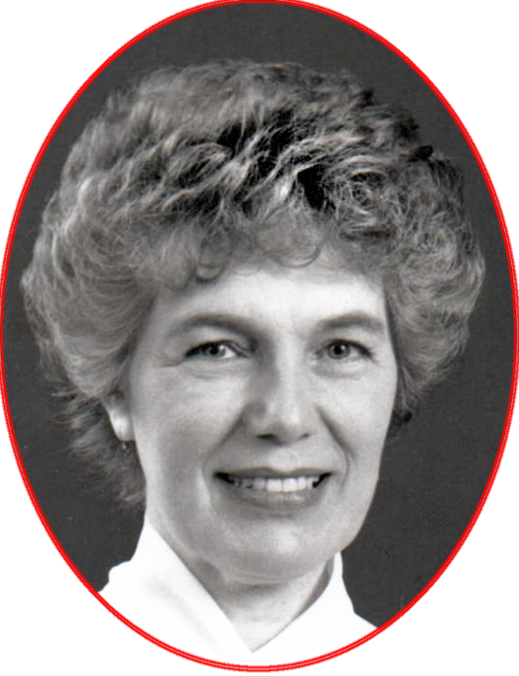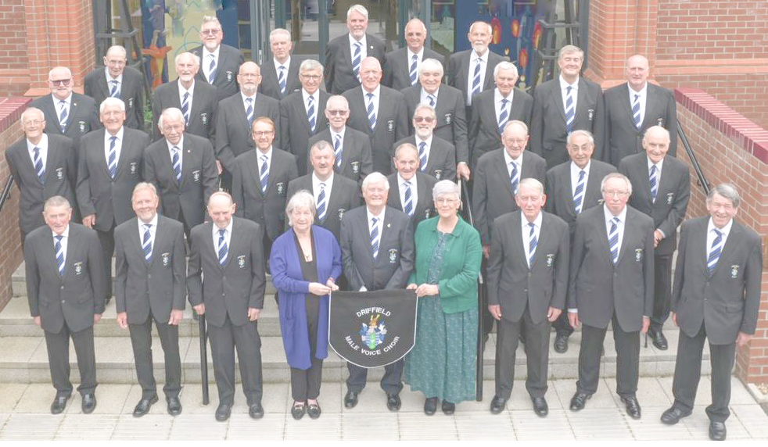

WITH DRIFFIELD MALE VOICE CHOIR

AT ALL SAINTS’ CHURCH MUSTON

FRIDAY 23RD JUNE 7.30PM

ADMISSION £10 INCLUDES REFRESHMENTS

ALL PROCEEDS IN AID OF ALL SAINTS’ CHURCH

FOR TICKETS CALL GODFREY ALLANSON 01723 449252

OR MAURICE BARBER 01723 890892